Introduction to Scheme: Part I

Scheme Expressions
We will be using Racket (Version 5.2 or above) for this class. (Software can be downloaded from the following link: http://racket-lang.org/download/)
Choose a language level of Advanced Student from the Language -> Choose Language menu.
When you start up the Scheme environment, you should see a window with two sections. You can type your functions into the upper half of the Dr. Racket window and click on the Run button. This loads the functions into the lower window, which works in an interactive mode.
In the lower window, the scheme interpreter reads in an expression, evaluates it, and then prints out the result.

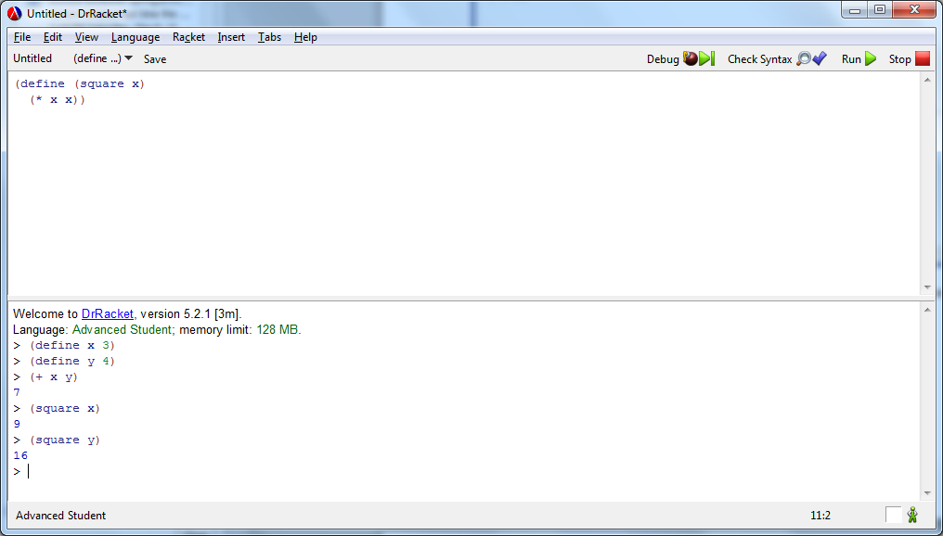

For example, to compute the value of (sin (π/2) + cos(0)), you will need to enter the following:

- (+ (cos 0) (sin (/ pi 2))

And the Scheme interpreter displays:

i2

The following are worth noting while working with the Scheme Interpreter:
- The Dr. Racket interpreter is case sensitive. You need to enter your expressions with the correct case.
- Scheme expressions are composed of forms. The most common Scheme form is function application. Scheme represents a function call f(x) as (f x). For example, cos(0) is written as (cos 0).
- Similarly, "+" is the name of the addition function that returns the sum of its arguments.
- Some functions, like "+" and "*", could take an arbitrary number of arguments. For example, "*" could as well take 2 arguments, as in "(* 2 3)", or 4 arguments, as in "(* 2 3 4 5)".
- In general, a function application form looks like (function argument₁ argument₂ ... argument_{n}). As in many programming languages (e.g. C/C++), Scheme evaluates function calls in applicative order, which means that all the argument forms are evaluated before the function is invoked. Some other forms, like the conditionals we will see later, are not evaluated in applicative order.
- Numeric values like 4 and 6 are called self-evaluating forms: they evaluate to themselves. To evaluate (+ 4 6) in applicative order, the forms 4 and 6 are respectively evaluated to the values 4 and 6 before they are passed as arguments to the + function.
Complex arithmetic expressions can be constructed from built-in functions like the following:
Numeric Functions | Meaning
(+ x₁ x₂ ... x_{n}) | The sum of x₁, x₂, ..., x_{n}
(* x₁ x₂ ... x_{n}) | The product of x₁, x₂, ..., x_{n}
(- x y) | Subtract y from x
(/ x y) | Divide x by y
(remainder x y) | The remainder of dividing x by y
(abs x) | The absolute value of x
(max x₁ x₂ ... x_{n}) | The maximum of x₁, x₂, ..., x_{n}
(min x₁ x₂ ... x_{n}) | The minimum of x₁, x₂, ..., x_{n}

Defining Functions
Scheme functions can be defined using the following general format:
(define (name-of-function parameter-list) function-body )

Look at the example below that returns the square of its input:

(define (squre x) (* x x))

The function can be called as shown below:
> (square 3)
9

> (square 4)
16

Loading and Executing Scheme Programs
When working with complex programs, it is usually desirable to edit the program with an editor, and save the source code instead of entering each line interactively.
; file.scm

(define (twice x) (+ x x))

For example, the above program, named file.scm, can be saved in a text file and loaded to the interpreter by clicking File->Open and selecting the source file from its location.

Once the file is loaded, the functions and names defined in the program can be accessed from the interpreter (in the lower section of the window) as shown below:

> (twice 3)
6

Control Structures: Recursions and Conditionals
Consider the definition of factorials:
 | n! = 1 |  | if n = 1
 | n! = n * (n - 1)! |  | if n > 1
We can implement a function to compute factorials using recursion as shown below:
(define (factorial n)
(if (= n 1)
1
(* n (factorial (- n 1)))))

The if form checks if n is one, and returns one if that is the case, or else returns n * (n - 1)!.
- The condition expression (= n 1) is a relational expression. It returns boolean values #t or #f.
Other relational operators include the following:
Relational Operators | Meaning
(= x y) | x is equal to y
(< x y) | x is less than y
(> x y) | x is greater than y
(<= x y) | x is no greater than y
(>= x y) | x is no less than y
- The if form is not a strict function (strict functions evaluate their arguments in applicative order). Instead, the if form evaluates the condition (= n 1) before further evaluating the other two arguments. If the condition evaluates to true, then only the second argument is evaluated, and its value is returned as the value of the if form. Otherwise, the third argument is evaluated, and its value is returned. Forms that are not strict functions are called special forms.
- The function is recursive. The definition of factorial involves invocation of itself. Recursion is the main mechanism for producing looping behavior. Specifically, the kind of recursion we are looking at is called linear recursion, in which the function may make at most one recursive call from any level of invocation.
To better understand the last point, we can compare the trace of the factorial function above with the Fibonacci function implemented below.)

Multiple Recursions
Recall the definition of Fibonacci numbers:
 | Fib(n) = n |  | for n = 0 or n = 1
 | Fib(n) = Fib(n-1) + Fib(n-2) |  | for n > 1
This definition can be directly translated to the following Scheme code:
(define fibonacci (n)
(if (or (= n 0) (= n 1))
n
(+ (fibonacci2 (- n 1)) (fibonacci (- n 2)))))

Logical Operators

Logical Operators | Meaning
(or x₁ x₂ ... x_{n}) | Logical or
(and x₁ x₂ ... x_{n}) | Logical and
(not x) | Logical negation

Lists
In Scheme, and also in Common Lisp, lists are containers that supports sequential traversal. A List is also a recursive data structure: its definition is recursive. For this reason, list manipulation is mostly done using recursive functions.
Scheme uses cons to construct lists, and car and cdr to access list elements.
Scheme, also provides a quote function to create a list of literal, so that the interpreter does not evaluate the form as a function call.
E.g. (quote (1 2 3 4)) creates the list (1 2 3 4)
Scheme also provides the short form (apostrophe) notation for quote.
E.g. '(1 2 3 4) creates the same list (1 2 3 4)

Working with Lists, cons, car, and cdr

constructing a list using list and cons

(list 1 2 3 4)

constructs the list containing the numbers 1, 2, 3, 4

(cons 1 (cons 2 (cons 3 (cons 4 null) ) ) )

constructs (recursively) the list containing the numbers 1, 2, 3, 4
null represents an empty list.

accessing list elements using using car and cdr

(car '(2 3 4))

4

(cdr '(2 3 4))

(3 4)

(car (cdr '(2 3 4))

3

(cdr (cdr '(2 3 4))

(4)

(cdr (cdr (cdr '(2 3 4))))

()

Using Recursion with Lists (Examples)
Example: The length scheme function determines the length of a list:
> (length '(2 3 4 5))
4

We can also write our own function which determines the length of lists as shown below:

(define (list-length l)
(if (null? l)
0
(+ 1 (list-length (cdr l)))))

(list-length '(2 3 4 5)) returns 4

Example: nth-element: determines the nth element of a list using linear recursion.
(define (nth-element n l)
(if (null? l)
null
(if (= 0 n)
(car l)
(nth-element (- n 1) (cdr l)))))

> (nth-element 2 '(2 3 4 5 6))
4

> (nth-element 4 '(2 3 4 5 6))
6

Example: list-member: determines if an element is a member of a list.
(define (list-member? e l)
(cond
((null? l) #f)
((eq? e (car l)) #t)
(else (list-member? e (cdr l)))))

> (list-member? 2 '(2 3 4 5 6))
#t

> (list-member? 4 '(2 3 4 5 6))
#t

> (list-member? 'a '(2 3 4 5 6))
#f

